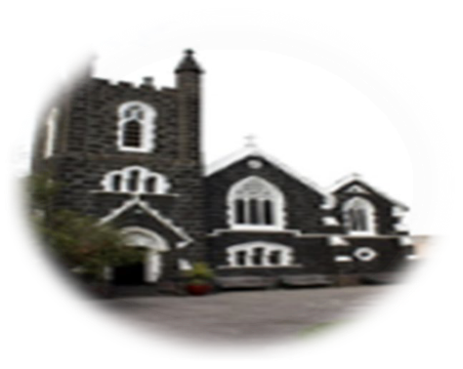

Fourth Sunday of Lent, Year B,
Laetare Sunday, 10th March 2024
First reading:
2 Chronicles 36:14-16,19-23
All the heads of the priesthood, and the people too, added infidelity to infidelity, copying all the shameful practices of the nations and defiling the Temple that the Lord had consecrated for himself in Jerusalem. The Lord, the God of their ancestors, tirelessly sent them messenger after messenger, since he wished to spare his people and his house. But they ridiculed the messengers of God, they despised his words, they laughed at his prophets, until at last the wrath of the Lord rose so high against his people that there was no further remedy.
Their enemies burned down the Temple of God, demolished the walls of Jerusalem, set fire to all its palaces, and destroyed everything of value in it. The survivors were deported by Nebuchadnezzar to Babylon; they were to serve him and his sons until the kingdom of Persia came to power. This is how the word of the Lord was fulfilled that he spoke through Jeremiah, ‘Until this land has enjoyed its sabbath rest, until seventy years have gone by, it will keep sabbath throughout the days of its desolation.’
And in the first year of Cyrus king of Persia, to fulfil the word of the Lord that was spoken through Jeremiah, the Lord roused the spirit of Cyrus king of Persia to issue a proclamation and to have it publicly displayed throughout his kingdom: ‘Thus speaks Cyrus king of Persia, “The Lord, the God of heaven, has given me all the kingdoms of the earth; he has ordered me to build him a Temple in Jerusalem, in Judah. Whoever there is among you of all his people, may his God be with him! Let him go up.”’
Responsorial Psalm
Psalm 136(137):1-6
Let my tongue be silenced, if I ever forget you!
By the rivers of Babylon there we sat and wept, remembering Zion; on the poplars that grew there we hung up our harps.
Let my tongue be silenced, if I ever forget you!
For it was there that they asked us, our captors, for songs, our oppressors, for joy. ‘Sing to us,’ they said, ‘one of Zion’s songs.’
Let my tongue be silenced, if I ever forget you!
O how could we sing the song of the Lord on alien soil? If I forget you, Jerusalem, let my right hand wither!
Let my tongue be silenced, if I ever forget you!
Oh let my tongue cleave to my mouth if I remember you not, if I prize not Jerusalem above all my joys!
Let my tongue be silenced, if I ever forget you!
Second reading Ephesians 2:4-10
God loved us with so much love that he was generous with his mercy: when we were dead through our sins, he brought us to life with Christ – it is through grace that you have been saved – and raised us up with him and gave us a place with him in heaven, in Christ Jesus. This was to show for all ages to come, through his goodness towards us in Christ Jesus, how infinitely rich he is in grace. Because it is by grace that you have been saved, through faith; not by anything of your own, but by a gift from God; not by anything that you have done, so that nobody can claim the credit. We are God’s work of art, created in Christ Jesus to live the good life as from the beginning he had meant us to live it.

ST AUGUSTINE’S CATHOLIC CHURCH
BOURKE ST, MELBOURNE 3000
Parish Priest: Mons. Stuart Hall.
melbournebourkest@cam.org.au
TEL: +61 3 9412 8426
Gospel Acclamation Jn3:16
Praise to you, Lord Jesus Christ, King of endless glory!
God loved the world so much that he gave his only Son:
everyone who believes in him has eternal life
Praise to you, Lord Jesus Christ, King of endless glory!
Gospel John 3:14-21
Jesus said to Nicodemus: ‘The Son of Man must be lifted up as Moses lifted up the serpent in the desert, so that everyone who believes may have eternal life in him. Yes, God loved the world so much that he gave his only Son, so that everyone who believes in him may not be lost but may have eternal life. For God sent his Son into the world not to condemn the world, but so that through him the world might be saved.
No one who believes in him will be condemned; but whoever refuses to believe is condemned already, because he has refused to believe in the name of God’s only Son. On these grounds is sentence pronounced: that though the light has come into the world men have shown they prefer darkness to the light because their deeds were evil. And indeed, everybody who does wrong hates the light and avoids it, for fear his actions should be exposed; but the man who lives by the truth comes out into the light, so that it may be plainly seen that what he does is done in God.
The Gospel of the Lord
ROSTER :10.30am: Priest: Rev. Jaycee Napoles; READERS: Jennifer, Felicia ALTAR SERVERS: Hananta, Marfel, Melinda, Aryo; MOC: Isabel 8pm: Priest: Rev. Michael Buck READER Raj
NOTICES: Come and pray the Stations of the Cross/Via Crucis every Friday night at 5.30pm in the Church from 16th Feb to 22 March, inclusive.
Join the scripture group for Lent. Wednesdays at 7pm in St Joseph’s Hall
MASS TIMES:
10.30AM and 8PM
Weekdays:
Tues, Wed, Fri at 1.05pm
Confession: Wednesday 12.30-12.50pm

